

M.SC. DATA ANALYTICS & TECHNOLOGIES
DAT7302 - BIG DATA ANALYTICS
ASSESSMENT 1 - Observational Analytics of Urban AQI (2021–2024)

STUDENT NAME: VICTOR ENE
STUDENT NUMBER: 2318217
MODULE TUTOR: DR ANCHAL GARG
SUBMITTED ON: 09/07/2025

Abstract
This study builds a reproducible Pandas to PySpark pipeline to quantify urban air quality from 2021 to 2024 using daily AQI and pollutant measures (PM2.5, PM10, NO2, SO2, CO, O3). After schema normalisation and winsorisation (1st–99th), SparkSQL aggregations reveal: (i) a two-year improvement in AQI followed by a modest reversal in 2024; (ii) a structural seasonal hierarchy (Summer best, Winter worst); (iii) a stable monthly ordering (Nov–Jan worst, Jul–Sep best); (iv) minimal weekday differences; and (v) that PM10/PM2.5 as the dominant AQI drivers.

Keywords: Air quality, AQI, PM10, PM2.5, PySpark, SparkSQL

Table of Contents
Abstract i
1. Introduction 1
1.1 Background 1
1.2 Business Problem 3
1.3 Business Questions 3
2. Methodology 4
2.1 Data scope and tools 4
2.2 Data Preparation 4
2.3 Feature engineering 4
3. Implementation 5
4. Results and Discussion 14
4.1 Data overview and quality 14
4.2 Yearly trends in AQI and pollutants 14
4.3 Seasons Airquality 15
4.4 Monthly Average AQI 16
4.5 Weekday Average AQI 18
4.6 Correlation Analysis 20
5. Conclusion 21
6. Recommendations and Future Work 22
6.1 Limitations 22
7.0 References 23

List of Figures
Figure 1 Initialise python libraries, read the data 4
Figure 2 Standardise column names, create date object 4
Figure 3 Check duplicates 4
Figure 4 Inspect data structure and identify missing values 5
Figure 5 Handle missing values 5
Figure 6 Outlier diagnosis 6
Figure 7 Airquality data boxplot 6
Figure 8 Outlier handling 6
Figure 9 Airquality data boxplot after winsorization 7
Figure 10 Save cleaned data 7
Figure 11 Install and start Spark session 7
Figure 12 Load cleaned data 7
Figure 13 View data and schema 8
Figure 14 Create required columns 8
Figure 15 Top rows with new columns 8
Figure 16 Yearly average of pollutants 9
Figure 17 Season pattern in AQI 9
Figure 18 Average mean of different seasons 9
Figure 19 Group by month for best/worst period 10
Figure 20 Monthly quality table 10
Figure 21 Group by day for best/worst period 10
Figure 22 Daily quality table 11
Figure 23 Correlation code snipet 11
Figure 24 Correlation table 11
Figure 25 Average AQI by year 12
Figure 26 Yearly trend 12
Figure 27 Seasonal Average AQI 13
Figure 28 Season-by-Year AQI table 13
Figure 29 Average AQI (year/Month) 14
Figure 30 Average AQI monthly each year 14
Figure 31 Average monthly AQI rank 15
Figure 32 Weekday Average AQI 15
Figure 33 Top 10 worst days 16
Figure 34 Top 10 best days 16
Figure 35 Correlation Matrix 16

1. Introduction

1.1 Background
Air quality monitoring has become increasingly critical for public health management and environmental policy development (Suman, 2021). The integration of big data analytics with traditional environmental monitoring provides unprecedented opportunities for understanding pollution patterns and their relationships with human activities (Dritsas and Trigka, 2025). Modern air quality assessment relies on multiple pollutant measurements including particulate matter (PM2.5, PM10), nitrogen dioxide (NO2​), sulfur dioxide (SO2​), carbon monoxide (CO), and ground-level ozone (O3​), which are often combined into composite indices like the Air Quality Index (AQI) for public communication (World Health Organization, 2021). The US Environmental Protection Agency (EPA) defines the AQI as a tool for reporting daily air quality, ranging from 0 to 500, with a higher value indicating a greater level of pollution and associated health concern. Globally, the World Health Organisation guidelines provide health-based recommendations to help countries protect their populations from air pollution, setting clear targets for key pollutants.
Given the size and heterogeneity of modern monitoring archives, leveraging scalable data tools is essential for improving the reproducibility and auditability of analyses. Recent literature underscores the pivotal role of big data in this domain. A comprehensive review by Huang et al. (2021) classifies air-quality analytics into spatial, temporal, and spatio-temporal approaches, linking these methods to core tasks such as real-time monitoring, forecasting, and traceability. Awasthi et al. (2025) outline how AI and big-data pipelines integrate multimodal sources, from monitor networks and meteorology to remote sensing, to improve prediction and decision support. Liu, Li and Duan (2025) in their book “Data Science in Air Quality Monitoring” explores data science applications in engineering environments, advocating for hybrid models combining machine learning with big data frameworks like PySpark for scalable analysis.
Cutting edge analytical methods are only one piece of the puzzle. To make a real-world impact, they need to be supported by strong governance and operational planning, Kaginalkar et al. (2022) addressed this need head on with their SmartAirQ framework, which lays out a practical structure for managing data from collection all the way to delivering public services, ensuring scientific insights actually inform policy. The payoff for getting this right is significant as surveys of machine learning applications show these new approaches consistently achieve better forecasts for AQI and pollutants than old methods, leveraging everything from sophisticated tree ensembles to deep learning (Xing et al., 2020; Méndez, Merayo and Núñez, 2023). This progress stands on the shoulders of foundational work in data science and urban informatics, and is exemplified by recent high-resolution models for pollutants like PM2.5 demonstrating the powerful results achievable by combining multiple data sources within a sophisticated spatio-temporal framework (Huang et al., 2021).
In this context, recent advances in distributed computing frameworks, such as Apache Spark, have transformed air quality analytics from simple descriptive statistics to sophisticated pattern recognition and predictive modelling by unifying batch, streaming and interactive workloads, the Spark SQL module integrates relational queries with procedural pipelines, which is well suited to environmental workflows that mix aggregation with custom transformations. These tools enable the processing of large-scale environmental datasets that were previously computationally prohibitive, allowing for more comprehensive analyses (Armbrust et al., 2015; Zaharia et al., 2016). Mirroring these best practices for modular and inspectable analytical pipelines, this project utilises Pandas for preprocessing and PySpark/SparkSQL for distributed computing, aggregated summaries, and correlation analysis.

1.2 Business Problem
City stakeholders such as public health, transport and environment teams need clear, reproducible evidence on how air quality evolves over time and which pollutants are most implicated when conditions are poor. Working with daily observations, the organisation must track improvement or deterioration, understand calendar effects across weekdays, holidays and seasons and pinpoint the drivers of high-AQI days so that advisories, traffic measures, enforcement and monitoring effort can be timed and targeted effectively.

1.3 Business Questions
1. What are the trends in AQI and pollutant over 2021–2024?
2. What seasonal patterns winter, spring, summer, autumn are observed in Air Quality
3. Which month and days have the worst or best average AQI
4. What correlations exist between pollutants and AQI?

2. Methodology
This report uses an observational analytics workflow on the daily air-quality dataset from 2021 to 2024, using descriptive and diagnostic analysing inquantifying temporal patterns and statistical associations without making causal claims (Hyndman and Athanasopoulos, 2021). The approach integrates thorough data preprocessing using Python (Pandas) with efficient aggregation and query operations in PySpark/SparkSQL to address the business questions

2.1 Data scope and tools
- Data: The dataset is comprised of daily observations for AQI and pollutants (PM2.5, PM10, NO₂, SO₂, CO, O₃) with other fields Year, Month, Date, Days and Holiday count.
- Software: The analysis is executed in Google Colab. Preprocessing is carried out in Python using Pandas and NumPy with Matplotlib for visualisations, while transformations, summaries and window operations are performed in PySpark using SparkSQL.

2.2 Data Preparation
- Schema normalisation: Standardised names and constructed a proper date column.
- Duplicate and missing values: Verified uniqueness of the records and assessed and handled missing values across variables using linear interpolation.
- Outliers: Diagnosed for outliers using IQR fences to quantify leverage points. Primary treatment via quantile winsorisation (1st–99th percentiles) to bound extremes while preserving rare episodes that are operationally relevant.

2.3 Feature engineering
We cast DateObj to a proper date, derive a WeekdayIndex and WeekdayName from Days and map Season as Winter, Spring, Summer or Autumn.

3. Implementation
The processing was carried out in Colab notebook with Pandas handling ingestion, interpolation, outlier bounding and other preprocessing, while Spark loads the cleaned file and is used for the other steps
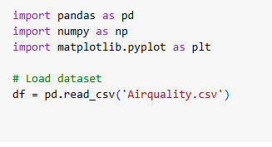
Figure 1 Initialise python libraries, read the data

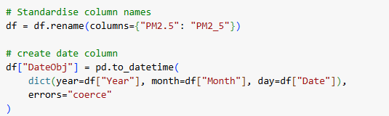
Figure 2 Standardise column names, create date object
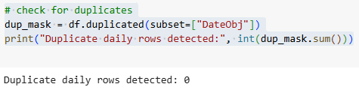
Figure 3 Check duplicates
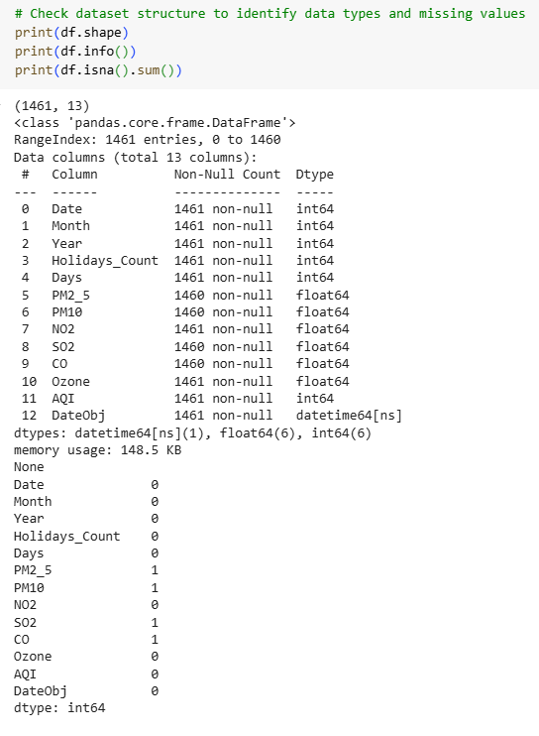
Figure 4 Inspect data structure and identify missing values
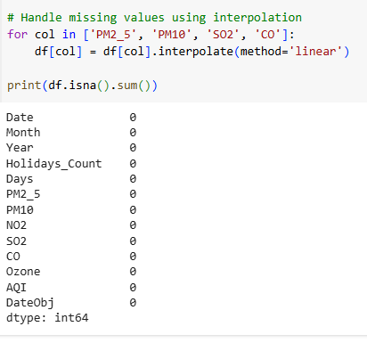
Figure 5 Handle missing values
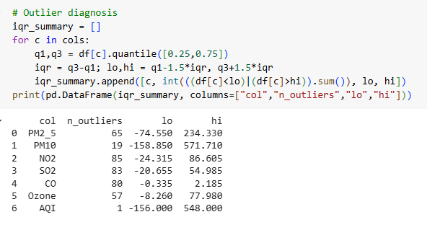
Figure 6 Outlier diagnosis
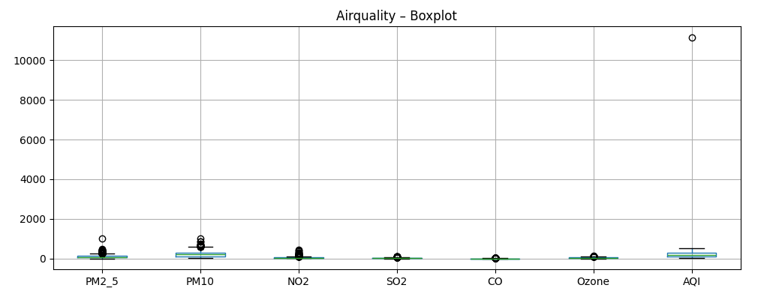
Figure 7 Airquality data boxplot
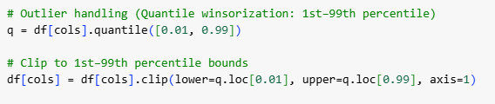
Figure 8 Outlier handling
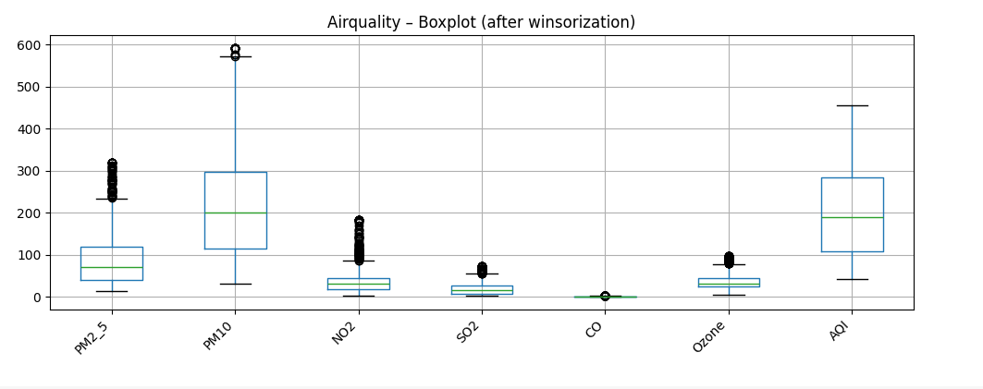
Figure 9 Airquality data boxplot after winsorization
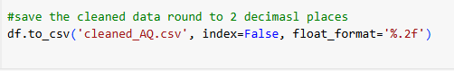
Figure 10 Save cleaned data
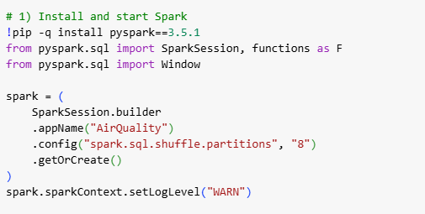
Figure 11 Install and start Spark session
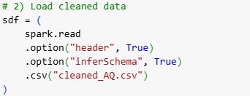
Figure 12 Load cleaned data
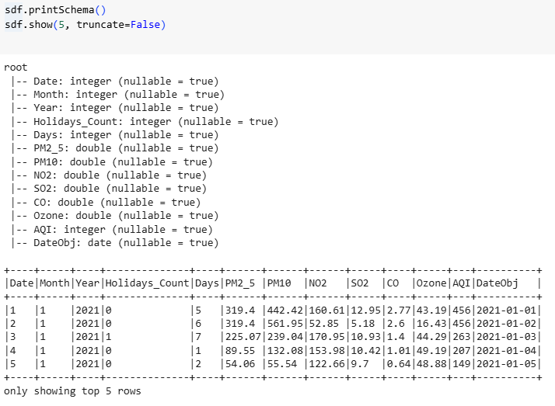
Figure 13 View data and schema
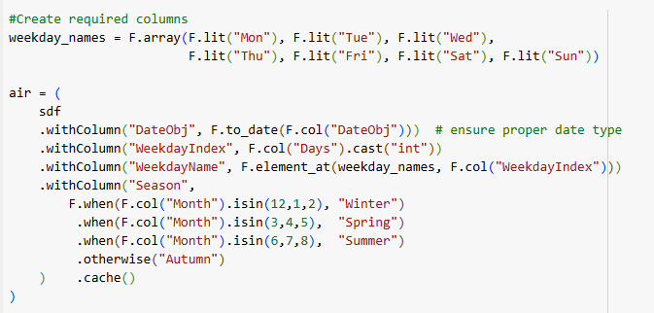
Figure 14 Create required columns
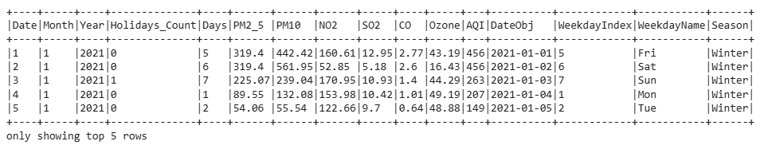
Figure 15 Top rows with new columns
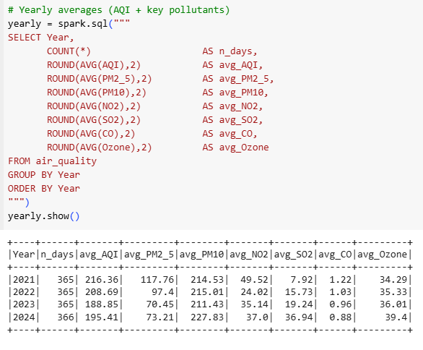
Figure 16 Yearly average of pollutants
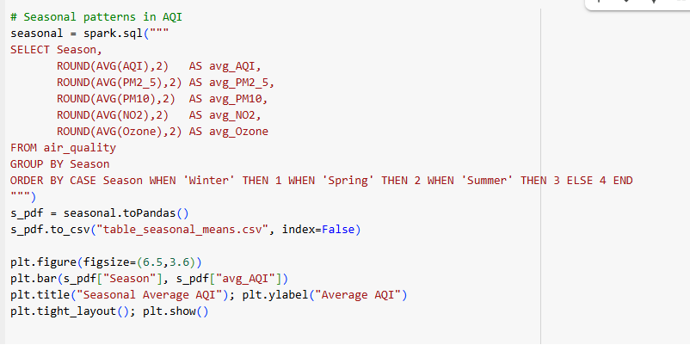
Figure 17 Season pattern in AQI
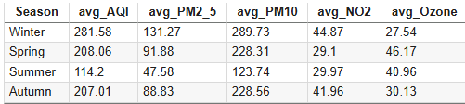
Figure 18 Average mean of different seasons
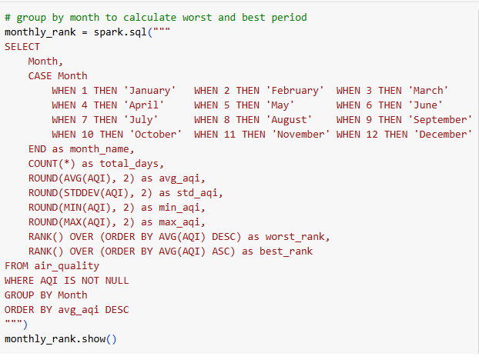
Figure 19 Group by month for best/worst period
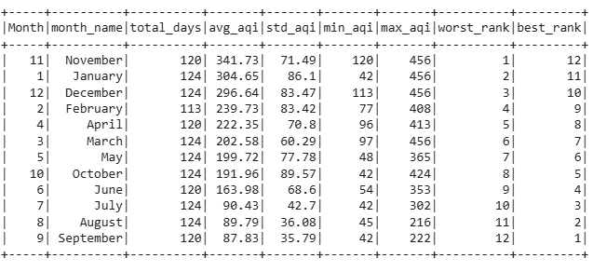
Figure 20 Monthly quality table
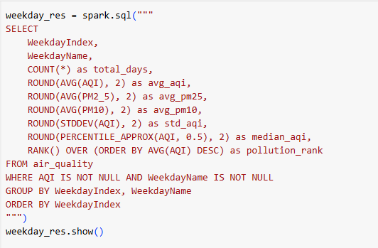
Figure 21 Group by day for best/worst period
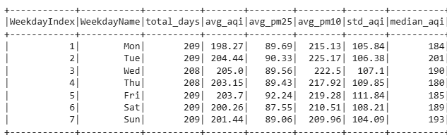
Figure 22 Daily quality table
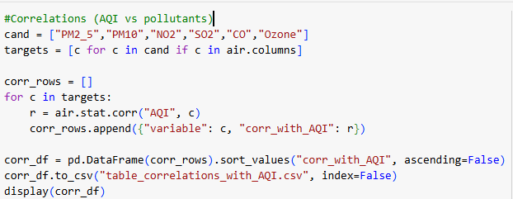
Figure 23 Correlation code snipet
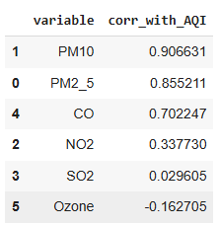
Figure 24 Correlation table

4. Results and Discussion

4.1 Data overview and quality
The data contained 1,461 unique daily records from 2021-01-01 to 2024-12-31 without any null values as shown if Figure 4 after getting a cleaned data for analysis we save the file and set the float to 2 decimal places to ensure correctness.

4.2 Yearly trends in AQI and pollutants
The year over year table in Figure 26 shows two consecutive improvements followed by a modest reversal. In 2022, the average AQI fell from 216.36 to 208.69 and in 2023, it declined further to 188.85 but in 2024, the trend worsened slightly, rising to 195.41. Overall, the small rebound in 2024, warrants continued monitoring to determine whether the 2024 uptick is indicative of a new pattern.

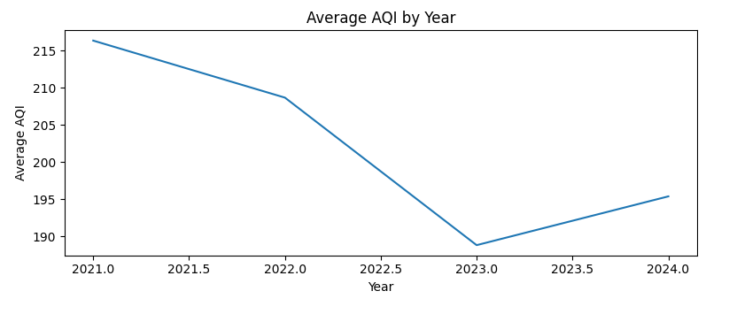
Figure 25 Average AQI by year

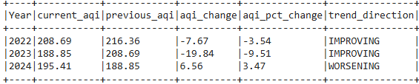
Figure 26 Yearly trend

4.3 Seasons Airquality
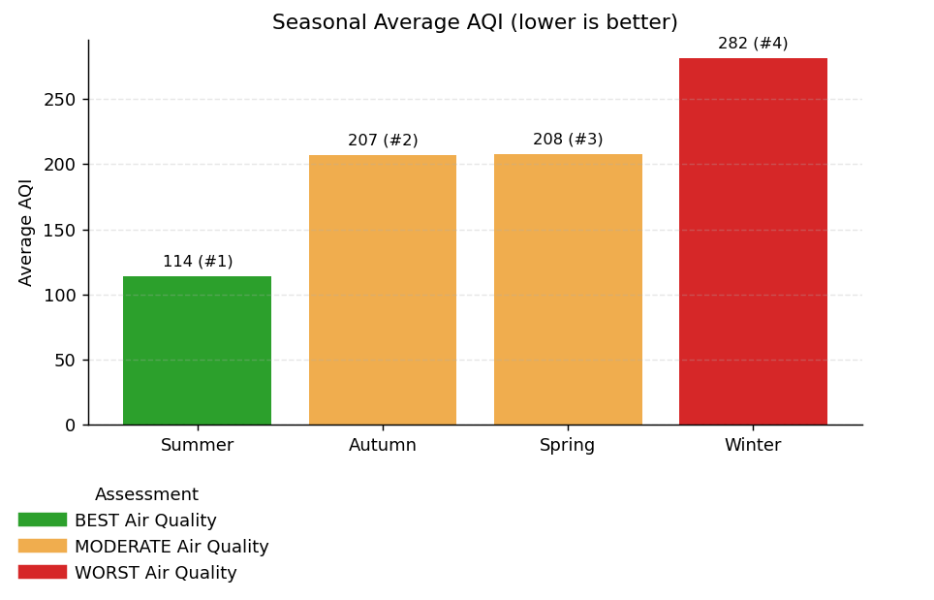
Figure 27 Seasonal Average AQI
Across all four years, among the different seasons Summer yields the best air quality and Winter the worst, with Autumn and Spring in the middle. The Winter 2021 peak of 344.98 marks the most severe seasonal period, whereas Summer 2023–2024 deliver the cleanest conditions from 102. The outlying Spring 2022 average of 252.09 is unusually high for that season. The close movement of AQI with PM10 and PM2.5 across seasons strengthens the case that coarse and fine particulates are the primary drivers of seasonal degradation, with winter amplifying combustion and resuspension processes.
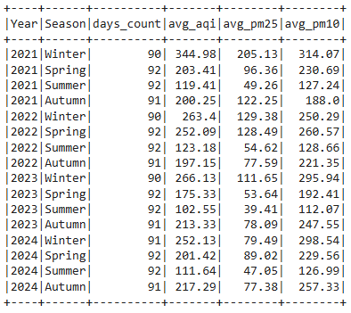
Figure 28 Season-by-Year AQI table

4.4 Monthly Average AQI
Daily observations were aggregated to the month level across 2021–2024. The year month line series shows a repeating annual cycle in which values rise sharply from late autumn into mid-winter and fall to in late summer as shown in Figure 29 below. The monthly ranking table confirms this pattern: the worst months by mean AQI are November (341.73), January (304.65), and December (296.64), whereas the best months are September (87.83), August (89.79), and July (90.43)
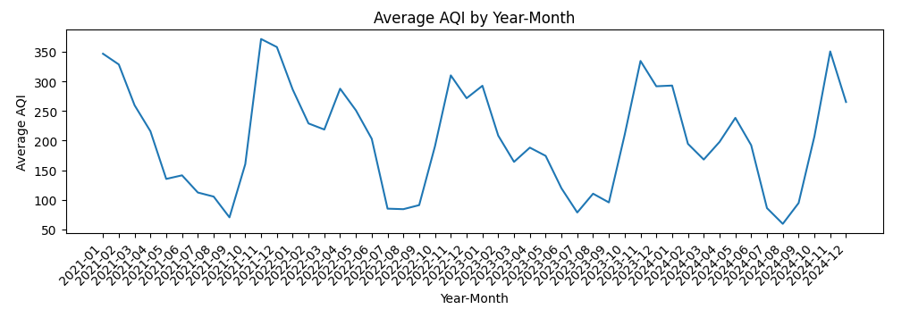
Figure 29 Average AQI (year/Month)
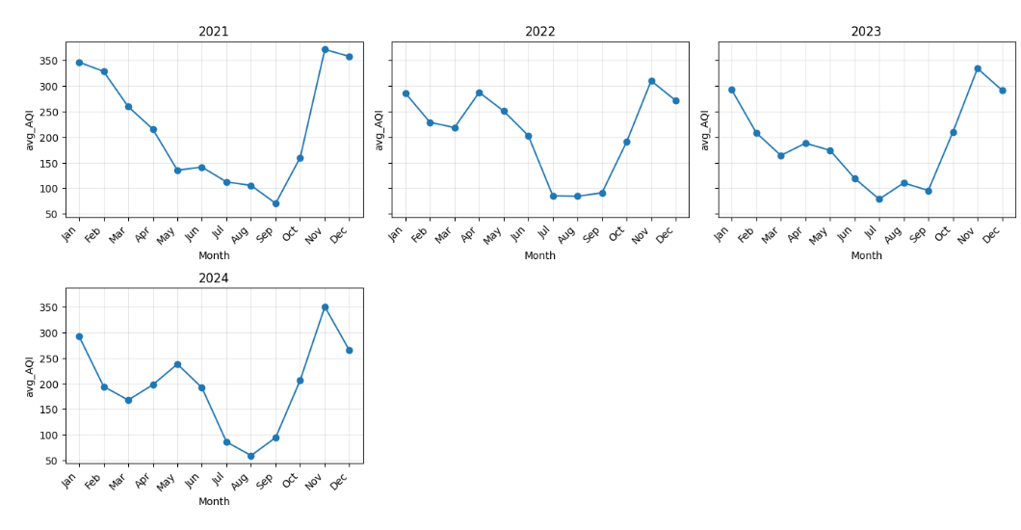
Figure 30 Average AQI monthly each year
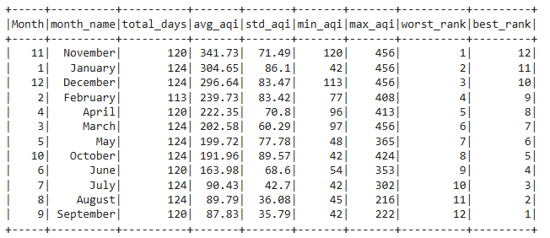
Figure 31 Average monthly AQI rank

4.5 Weekday Average AQI
Daily observations were aggregated by day of week after preprocessing and the Top and Bottom 10 individual days were identified using a windowed rank on AQI. The weekday means are tightly clustered, indicating only modest differences by day. Wednesday (205.00), Tuesday (204.44), and Friday (203.70) are marginally higher, while Monday (198.27) is lowest.
The worst days concentrate in winter (2021-12-23/24/25/26, 2023-01-08, 2021-01-02) with a few late-autumn spikes (2022-11-03, 2021-11-12) and one spring outlier (2021-03-31). By contrast, the best days occur in late summer/early autumn (e.g., 2021-07-28, 2021-09-02, 2021-10-18, 2022-09-23/24) with an isolated clean winter day (2022-01-09).
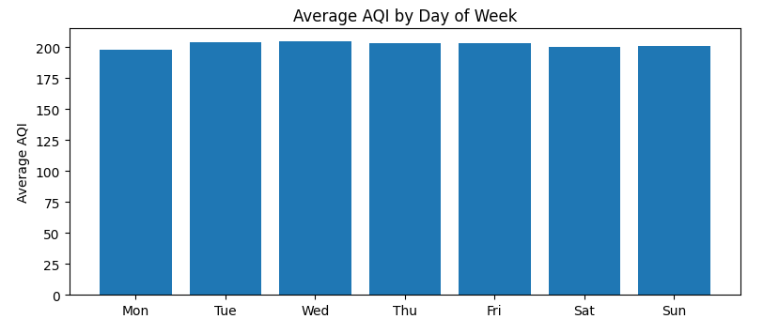
Figure 32 Weekday Average AQI

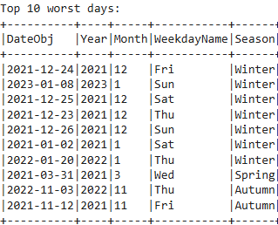
Figure 33 Top 10 worst days
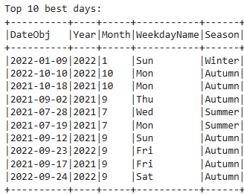
Figure 34 Top 10 best days

4.6 Correlation Analysis

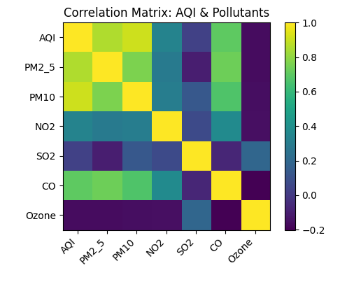
Figure 35 Correlation Matrix
We estimated Pearson correlations between AQI and all measured pollutants using daily observations, and visualised the pairwise relationships in the heatmap. The matrix indicates that AQI is most strongly associated with particulate matter, especially PM10 (r ≈ 0.9066) and PM2.5 (r ≈ 0.8552), with CO (r ≈ 0.7022). In contrast, NO₂ (r ≈ 0.3377) shows a weak positive association, SO₂ (r ≈ 0.0296) is negligible, and Ozone exhibits a weak negative association (r ≈ −0.1627), suggesting ozone peaks tend to occur under different atmospheric conditions than particulate episodes. The heatmap also reveals inter-pollutant coupling, notably PM2.5–PM10 (r ≈ 0.7648) and PM2.5–CO (r ≈ 0.7363), implying shared conditions and cautioning that these variables may be collinear in predictive models.

5. Conclusion
We used a clear, repeatable process combining Pandas and PySpark to dig into air quality trends from 2021 to 2024. The data tells a consistent story, summers are the cleanest with AQI around 114, while winters are the worst AQI around 282. Months follow a predictable pattern too, November through January are the worst, while July through September are the best. Weekdays do not vary much (AQI between 198 and 205), so it is the season that drives the differences. PM10 and PM2.5 are the main reasons behind poor air quality with strong correlations of 0.91 and 0.86, and CO plays a supporting role correlation around 0.70. Air quality improved from 2021 to 2023, but 2024 showed a slight backslide, tied to a PM10 spike.

6. Recommendations and Future Work
To address the identified air quality issues, immediate actions should target the critical November-to-January period when PM10 and PM2.5 drive AQI spikes. Councils should ramp up street sweeping, enforce stricter construction dust controls, and optimise traffic flow during winter seasons. Targeted campaigns on fuel quality and smoke enforcement during still, cold nights is key. Key performance indicators should include November AQI as an early warning metric. Other metrics and indicators should be used to perform further predictive analysis.

6.1 Limitations
a. Observational scope: the analysis highlights patterns and relationships but does not account for weather or traffic which can skew daily AQI readings.
b. Outlier policy: Capping extreme values (1st–99th percentiles) stabilises averages but may underplay severe pollution events. Top and Bottom 10 tables preserve these narratives, but different outlier handling could alter results.
c. Generalisation: Changes in emissions, vehicles, or heating practices could shift patterns in the future.
d. Measurement and coverage: If data comes from just a few stations, it may not represent the wider area. Sensor drift or maintenance issues could add uncertainty without rigorous quality checks.
7.0 References
Armbrust, M. et al. (2015) “Spark SQL,” in Proceedings of the 2015 ACM SIGMOD International Conference on Management of Data. New York, NY, USA: ACM, pp. 1383–1394. Available at: https://doi.org/10.1145/2723372.2742797.
Awasthi, Amit. et al. (2025) Artificial intelligence for air quality monitoring and prediction. CRC Press.
Dritsas, E. and Trigka, M. (2025) “Remote Sensing and Geospatial Analysis in the Big Data Era: A Survey,” Remote Sensing, 17(3), p. 550. Available at: https://doi.org/10.3390/rs17030550.
Hernan, M.A.. and Robins, J.M. (2024) Causal inference : what if. Taylor and Francis.
Huang, W. et al. (2021) “An overview of air quality analysis by big data techniques: Monitoring, forecasting, and traceability,” Information Fusion, 75, pp. 28–40. Available at: https://doi.org/10.1016/j.inffus.2021.03.010.
Hyndman, R.J.. and Athanasopoulos, George. (2021) Forecasting : principles and practice. OTexts.
Kaginalkar, A. et al. (2022) “SmartAirQ: A Big Data Governance Framework for Urban Air Quality Management in Smart Cities,” Frontiers in Environmental Science, 10. Available at: https://doi.org/10.3389/fenvs.2022.785129.
Liu, H., Li, Y. and Duan, Z. (2025) Data Science in Air Quality Monitoring. Singapore: Springer Nature Singapore. Available at: https://doi.org/10.1007/978-981-96-5777-3.
Méndez, M., Merayo, M.G. and Núñez, M. (2023) “Machine learning algorithms to forecast air quality: a survey,” Artificial Intelligence Review, 56(9), pp. 10031–10066. Available at: https://doi.org/10.1007/s10462-023-10424-4.
Seinfeld, J.H.. (2016) Atmospheric Chemistry and Physics : From Air Pollution to Climate Change. John Wiley & Sons, Incorporated.
Suman (2021) “Air quality indices: A review of methods to interpret air quality status,” Materials Today: Proceedings, 34, pp. 863–868. Available at: https://doi.org/10.1016/j.matpr.2020.07.141.
U.S. EPA (2021) ‘Air Quality Index (AQI) Basics’. United States Environmental Protection Agency
World Health Organization (2021) WHO global air quality guidelines : particulate matter (PM2.5 and PM10), ozone, nitrogen dioxide, sulfur dioxide and carbon monoxide. WHO European Centre for Environment and Health.
Xing, J. et al. (2020) “Deep Learning for Prediction of the Air Quality Response to Emission Changes,” Environmental Science & Technology, 54(14), pp. 8589–8600. Available at: https://doi.org/10.1021/acs.est.0c02923.
Zaharia, M. et al. (2016) “Apache Spark,” Communications of the ACM, 59(11), pp. 56–65. Available at: https://doi.org/10.1145/2934664.

